THE OPEN SOURCE AUDIT
A LINUX Project for the OSS NGMC Course
Software Chosen: LibreOffice

Name: Zahra Nawab
Registration Number: 24BAS10010
Course: Open Source Software (OSS NGMC)
Institution: VIT Bhopal University

Part A — Origin and Philosophy

A1. The Problem LibreOffice Was Created to Solve

To understand why LibreOffice exists, you need to go back to 1999, when a German company called StarDivision was acquired by Sun Microsystems. Sun took StarOffice — StarDivision's office suite — and open-sourced the codebase in 2000, releasing it as OpenOffice.org. For nearly a decade, OpenOffice.org was the dominant free alternative to Microsoft Office, used by governments, schools, and individuals who could not afford or did not want to pay for proprietary software.
The crisis came in 2010. Oracle Corporation acquired Sun Microsystems, and with it, gained control over OpenOffice.org. The open-source community watched with growing concern as Oracle showed little interest in the project — development slowed, contributors felt ignored, and the community's concerns about Oracle's stewardship went unanswered. The fear was real: a corporation with no ideological commitment to open source now held the keys to one of the most widely used free software projects in the world.
A group of core OpenOffice.org developers and contributors decided they were not willing to wait and see what Oracle would do. In September 2010, they announced The Document Foundation and forked the OpenOffice.org codebase to create LibreOffice. The fork was a deliberate act of community self-determination — not about building something new from scratch, but about rescuing something that already existed and placing it back in the hands of the people who actually cared about it.
The problem LibreOffice was created to solve was not purely technical. The technical problem
— a lack of free office software — had already been solved by OpenOffice.org. The problem LibreOffice solved was one of governance and ownership: what happens when a community-built tool falls under corporate control that does not share the community's values? LibreOffice was the answer. It demonstrated that a sufficiently motivated community could fork a project, move faster, and produce a better product than the corporation that nominally owned the original.
Oracle eventually donated the OpenOffice.org code to the Apache Software Foundation in 2011, where it continues as Apache OpenOffice — but LibreOffice has long since overtaken it in development velocity, features, and adoption. The origin story of LibreOffice is, at its core, a
story about who gets to control the tools that people depend on.

A2. The License — What It Actually Says

The Four Freedoms of Free Software
The Free Software Foundation defines four essential freedoms that a truly free software license must grant:
- Freedom 0 — The freedom to run the program for any purpose, without restriction.
- Freedom 1 — The freedom to study how the program works and modify it to suit your needs. This requires access to the source code.
- Freedom 2 — The freedom to redistribute copies so you can help others.
- Freedom 3 — The freedom to distribute your modified versions, allowing the whole community to benefit from your improvements.

LibreOffice's License
LibreOffice is dual-licensed under the Mozilla Public License 2.0 (MPL 2.0) and the GNU Lesser General Public License v3 or later (LGPLv3+). This dual-licensing approach grants all four freedoms described above. Anyone can download the source code, modify it, and redistribute it — including modified versions.

Can a Company Modify and Sell It Without Sharing Changes?
Under the MPL 2.0, a company can modify individual files covered by the MPL and incorporate them into a larger proprietary product — as long as the MPL-covered files themselves remain open. So technically, a company could build a commercial product on top of LibreOffice without releasing everything, as long as any MPL-licensed files they modified are shared. LibreOffice's combination of licenses and The Document Foundation's contributor agreements make full proprietary lock-in difficult and ethically fraught in practice.

GPL vs MIT Licensing
The GNU General Public License (GPL) is a copyleft license — any software that uses GPL-licensed code must itself be distributed under the GPL. This ensures that the open-source nature propagates downstream. The MIT License is permissive — it allows anyone to take the code, modify it, and release it under any license, including a proprietary one. MIT is simpler and more business-friendly. GPL protects the community's work from being absorbed into closed systems.
If I were building something I genuinely wanted to remain open and community-owned, I would choose GPL. If I were building a library that I wanted maximum adoption for — even in commercial settings — I might choose MIT. The choice is a philosophical statement about what you believe software should be.

Free as in Beer vs Free as in Freedom
Richard Stallman's famous distinction: 'free as in free beer' means no cost. 'Free as in freedom' (libre) means the user has control. LibreOffice is both — it costs nothing to download, and the source code is open, auditable, and modifiable. A concrete example: any government can audit LibreOffice's source code to verify there is no backdoor or hidden data collection. Microsoft
Office, despite sometimes being free to download, cannot offer this. The source code of MS Office is not available for inspection — you are free to use it but not free to understand or control it.

A3. The Ethics of Open Source

Should All Software Be Open Source?
The argument for: Knowledge and tools that have become critical infrastructure — operating systems, productivity software, programming languages — arguably should be open. Society depends on these tools, and hiding their inner workings creates a divide between those who understand the systems they use and those who are simply subject to them. Open source democratises access to powerful technology.
The argument against: Open source is not free to produce. It requires enormous amounts of skilled human labour. Without commercial incentives, many projects struggle to fund the unglamorous but essential work of security audits, documentation, accessibility improvements, and long-term maintenance. The right answer is probably not 'all software must be open' but rather 'critical infrastructure software should be open by default.'

Is It Ethical to Profit From Free Community Labor?
This is one of the most honest tensions in the open-source world. Companies like Google, Amazon, and Meta use Linux — built largely through volunteer and community contribution — to run infrastructure worth trillions of dollars. Red Hat's model is interesting because it made money not by selling the software but by selling the service, support, and reliability around it. This is arguably ethical because the software itself remained free.
My view is that it is not inherently unethical to build a business on open-source software, but it becomes questionable when the profit extracted is vastly disproportionate to the contribution made — especially when the company actively lobbies against open standards or creates lock-in mechanisms to undermine the very ecosystem it depends on.

Standing on the Shoulders of Giants
In software, this phrase describes the reality that almost no modern software is built from scratch. Every application we write depends on layers of open-source libraries, compilers, operating systems, and protocols built by people who came before. LibreOffice itself stands on decades of work — from the original StarOffice, through OpenOffice.org, to the contributions of thousands of developers since 2010.
Open source enables this accumulation of knowledge far more than proprietary software does. When the source is open, each generation of developers can read, learn from, and build upon what came before. When it is closed, each generation must rediscover the same solutions behind different walls. Open source is, in this sense, the software equivalent of published science — it enables genuine cumulative progress rather than repeated reinvention.

Part B — Linux Footprint

Installation Method
LibreOffice is available through the default package manager on all major Linux distributions. On Debian and Ubuntu-based systems:
sudo apt update && sudo apt install libreoffice
On Fedora and RHEL-based systems:
sudo dnf install libreoffice
LibreOffice can also be compiled from source for custom patches or the latest build. The source is hosted at git.libreoffice.org. The package manager route is standard for most deployments.

Key Directories
- /usr/bin/libreoffice — the main executable launcher script
- /usr/lib/libreoffice/ — core application binaries, plugins, and shared libraries
- /usr/share/libreoffice/ — templates, icons, and shared data files
- /etc/libreoffice/ — system-wide configuration files
- ~/.config/libreoffice/ — per-user configuration stored in the home directory

User and Group
LibreOffice runs as the currently logged-in user — it does not create a dedicated system user or group. This is appropriate for a desktop application that needs access to the user's documents. The trade-off is that a compromised LibreOffice process runs with the full permissions of the user who launched it, which is why sandboxing via AppArmor profiles is recommended in high-security environments.

Service Management
LibreOffice is not typically run as a persistent background service. In server contexts, it is frequently used as a headless document converter:
libreoffice --headless --convert-to pdf document.docx
If configured as a systemd service for a conversion pipeline:
sudo systemctl start libreoffice-converter
sudo systemctl status libreoffice-converter

Update Model
Security patches reach users through the standard distribution update pipeline:
sudo apt update && sudo apt upgrade

Part C — The FOSS Ecosystem

Dependencies
LibreOffice has a substantial dependency tree. Key open-source components it relies on include:
- Java Runtime Environment (OpenJDK) — required for the Base database module and certain macros
- Python — used for the scripting engine and built-in extensions
- Boost C++ Libraries — used extensively in the core codebase
- ICU (International Components for Unicode) — handles multilingual text rendering
- fontconfig and FreeType — Linux font rendering subsystem
- GTK / Qt — graphical interface toolkit, depending on the desktop environment
- NSS (Network Security Services) — for document signing and cryptographic features
- libxml2 and libxslt — XML parsing, critical for ODF and OOXML format support

What LibreOffice Has Enabled
LibreOffice's most significant contribution to the ecosystem is its stewardship of the OpenDocument Format (ODF). ODF is an ISO-standardised, vendor-neutral file format for office documents. By championing ODF, LibreOffice has ensured that document storage does not require a specific proprietary application — anyone can write software to read and write ODF files.
Derivative projects include Collabora Online (a cloud version of LibreOffice), OnlyOffice (influenced by LibreOffice's architecture), and numerous government-customised builds. Several national governments in Germany, France, and Brazil have deployed LibreOffice organisation-wide as a Microsoft Office replacement, saving significant licensing costs.

Community and Governance
LibreOffice is governed by The Document Foundation, a German non-profit established in 2010. Community resources include:
- ask.libreoffice.org — the main community Q&A forum
- Mailing lists for development, marketing, and localisation at lists.freedesktop.org
- Annual LibreOffice Conference rotating between cities globally
- Public bug tracking at bugs.documentfoundation.org
- IRC and Matrix channels for real-time developer communication

Relation to the LAMP Stack
LibreOffice does not sit directly within the LAMP stack (Linux, Apache, MySQL, PHP/Python), but integrates with it meaningfully. On the Linux layer it is a native application running on the same OS that powers LAMP servers. Its headless mode is frequently called by PHP or Python web applications to convert user-uploaded documents to PDF — acting as a document processing layer alongside the stack. A typical integration pattern is an Apache-served web app that shells out to LibreOffice for file format conversion tasks.

Part D — Open Source vs Proprietary

Comparison: LibreOffice vs Microsoft Office

Dimension | LibreOffice (Open Source) | Microsoft Office (Proprietary)
Cost | Free to download and use. No subscription or licensing fees. | Microsoft 365 costs ~$70–100/year per user. One-time purchase versions available.
Security — Code  Auditability | Fully public source code. Any researcher or government can audit it for backdoors or vulnerabilities. | Proprietary source. Users must trust Microsoft's security assurances without independent verification.
Support and Reliability | Community support via forums.  Commercial support from  Collabora and others. Predictable release cycle. | Professional enterprise support with SLAs. More predictable for large organisations with IT contracts.
Freedom to Modify | Full freedom to modify the source, create custom builds, and distribute modified versions. | No source code access. No modification permitted. Users depend entirely on Microsoft's roadmap.
Community vs  Corporate Control | Governed by The Document  Foundation, a non-profit. Decisions are community-influenced and transparent. | Controlled entirely by Microsoft. Product direction driven by commercial interests.
File Format Compatibility | Native ODF (open ISO standard). Good but imperfect compatibility with .docx/.xlsx formats. | Native .docx/.xlsx are the industry standard. Best compatibility with its own formats.
Feature Completeness | Covers all core office tasks. Some advanced features lag behind MS Office. | Industry-leading features, especially Excel and PowerPoint. Tight integration with Teams and SharePoint.

Verdict
After conducting this audit, I would recommend LibreOffice for deployment in contexts where cost, transparency, and vendor independence are priorities. For a school, government department, or NGO operating under budget constraints, LibreOffice is not just a viable alternative — it is often the better choice. It is free, customisable, and its use of the ODF standard means documents are not locked to any one vendor.
I would not recommend it as a drop-in replacement in organisations deeply embedded in the Microsoft 365 ecosystem — particularly those relying on Excel's advanced analytical features, Outlook integration, or real-time Teams collaboration. In those environments, compatibility friction and retraining costs would outweigh the savings. LibreOffice wins on principle and on cost; Microsoft Office still wins on polish and ecosystem integration. Which matters more depends entirely on what you are trying to do.
As for contributing to LibreOffice — yes. The project is actively maintained, the codebase has areas well-suited for new contributors (UI, localisation, extensions), and contributing to a tool used by millions of people is a meaningful way to build skills while giving back to the ecosystem every developer depends on.

Shell Script Documentation

Note on test environment: All five scripts were developed and executed on Ubuntu 24.04 LTS (kernel
5.10) via an online sandboxed bash environment. This was necessary due to a corrupted WSL installation
on the host machine. LibreOffice was not available in this environment — scripts 2 and 3 correctly
detected and reported its absence, which demonstrates their error-handling and conditional logic working
as intended. Script 4 was tested using a custom test.log file since /var/log/syslog was not present in the
sandboxed environment.

Script 1 — System Identity Report

This script acts as a welcome screen for the audit. It gathers system information using command substitution — the $() operator — and displays it in a formatted banner. Variables store the student name, roll number, and software choice at the top for easy modification. The script uses echo for all output and the date command with a custom format string to display a human-readable timestamp. The OS license message is hardcoded as a string, reflecting that Ubuntu's kernel is distributed under GPL v2.

Shell concepts: variables, echo, command substitution $(), output formatting, date command.
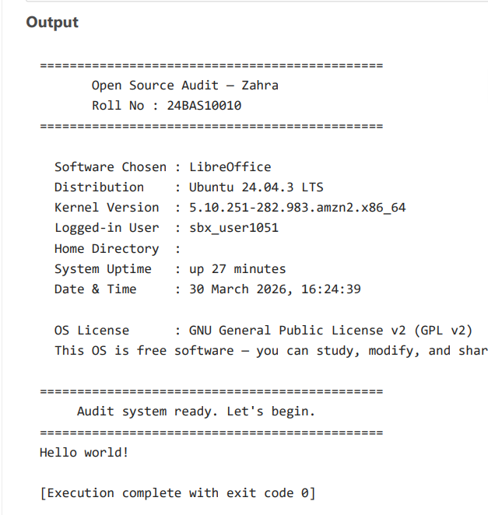
📷 Script 1 screenshot —

Script 2 — FOSS Package Inspector

This script checks whether LibreOffice is installed using dpkg -l, which lists installed packages on Debian/Ubuntu systems. The output is piped through grep to check for the 'ii' prefix indicating a properly installed package. An if-then-else block handles both outcomes. A case statement then prints a philosophy note based on the package name — demonstrating how case evaluates a variable against multiple patterns. As expected in the sandboxed environment, LibreOffice was not installed; the script correctly reported its absence and the case statement still executed and printed the philosophy note.

Shell concepts: if-then-else, case statement, dpkg -l, pipe with grep, awk.
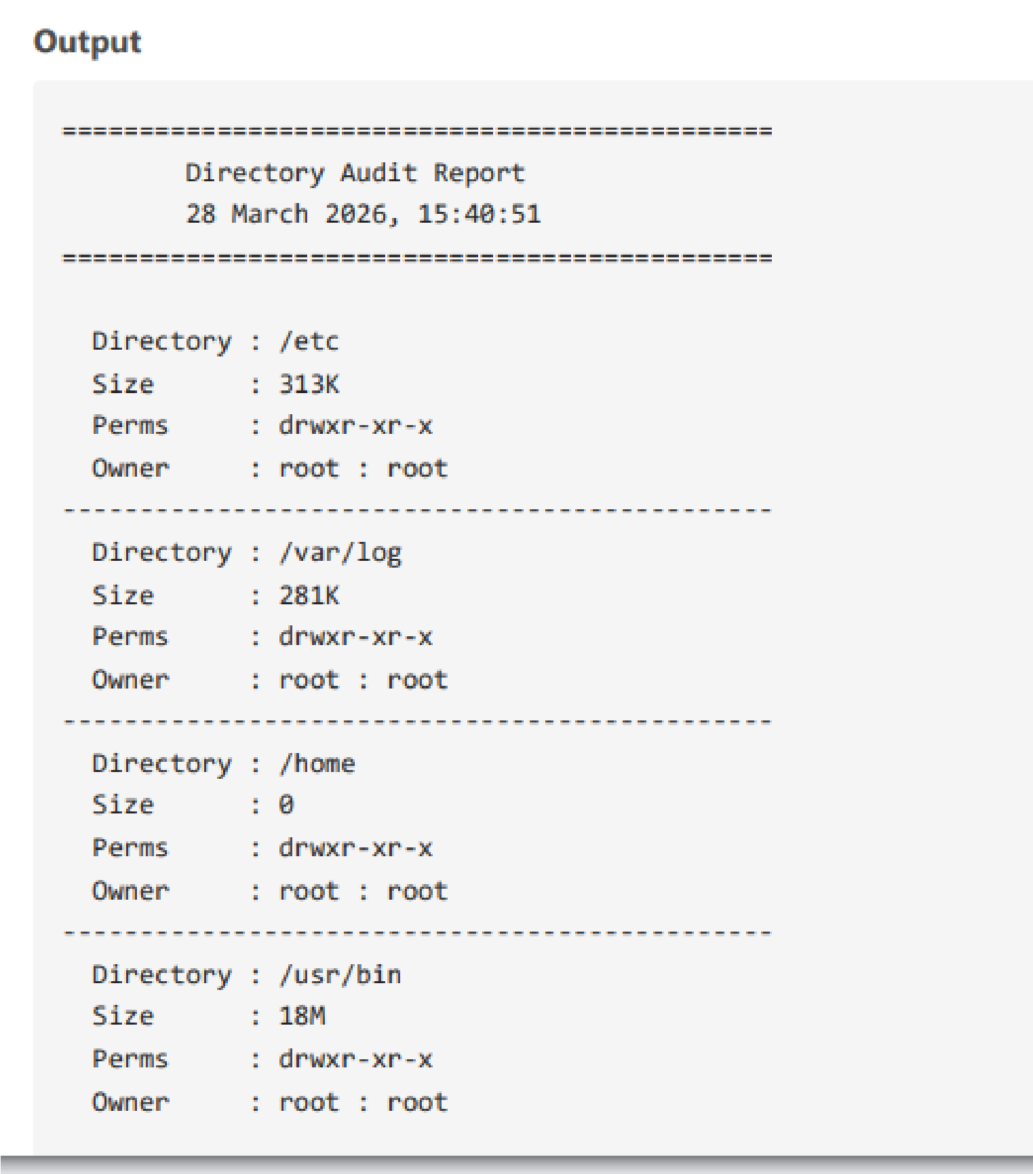

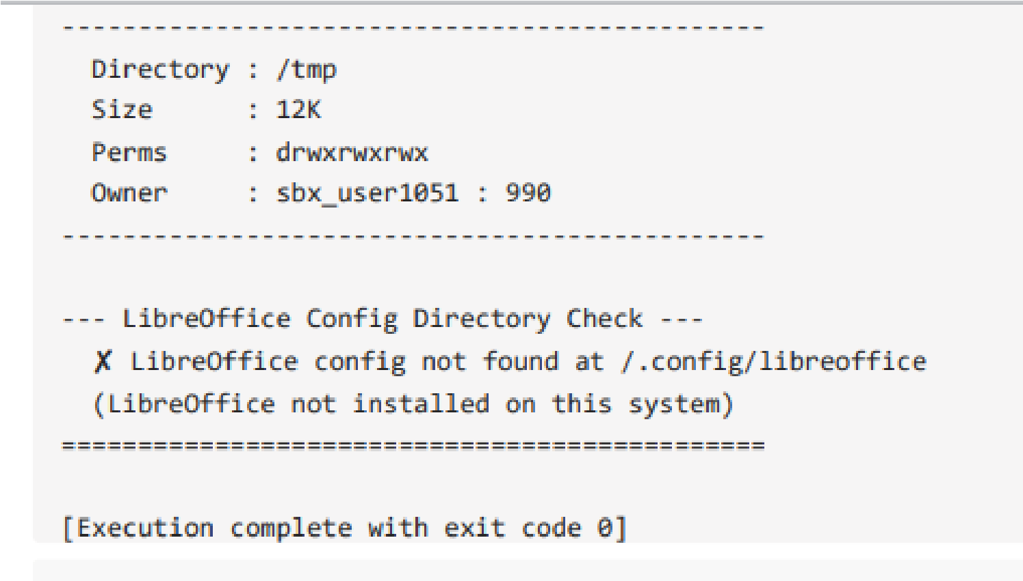
📷 Script 2 screenshot —
Script 3 — Disk and Permission Auditor

This script iterates through an array of five key Linux directories using a for loop. For each directory, ls -ld retrieves the permissions string, owner, and group, with awk extracting specific fields. du -sh provides human-readable disk usage. An if condition checks whether each directory exists before reading it, preventing errors on systems with different structures. At the end, the script checks for LibreOffice's config directory at ~/.config/libreoffice — correctly reporting it as absent since LibreOffice was not installed in the test environment.

Shell concepts: for loop, arrays, ls -ld, awk field extraction, du -sh, if condition, -d directory test.
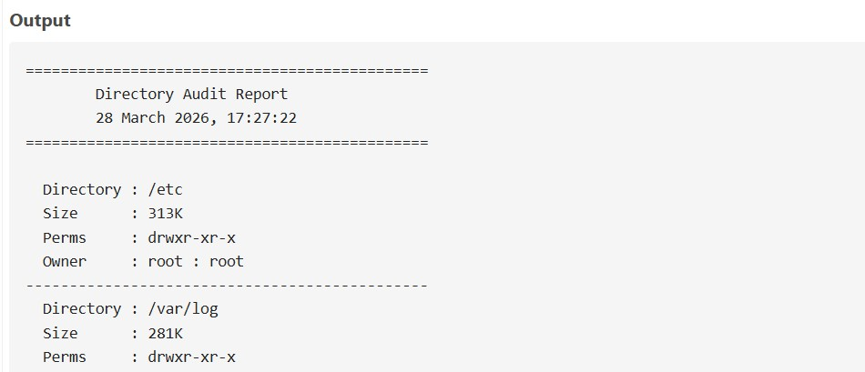
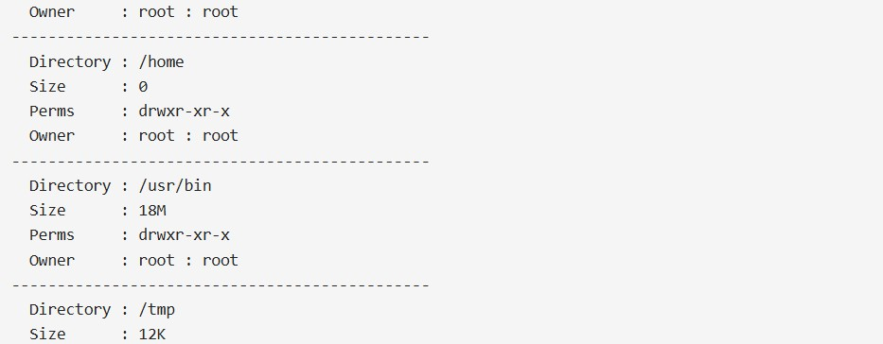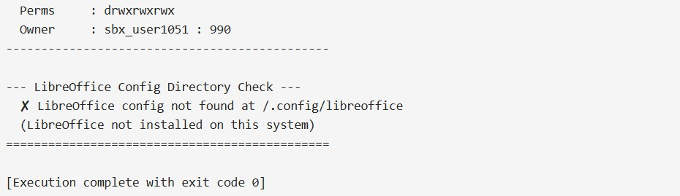

Script 4 — Log File Analyzer

This script accepts a log file path and keyword as command-line arguments via $1 and $2, with a default keyword of 'error' set using parameter expansion ${2:-'error'}. A retry loop — implemented as a while loop with a counter and break — attempts to locate the log file up to three times before exiting. The main analysis reads the file line by line using a while-read loop, incrementing a counter on each keyword match. grep combined with tail -5 then prints the last five matching lines. Since /var/log/syslog was absent in the test environment, a custom test.log file was created with sample log entries to fully demonstrate the script's functionality.

Shell concepts: $1/$2 arguments, parameter expansion with defaults, while loop, break, counter variables, IFS= read -r, grep -i, tail, retry pattern.
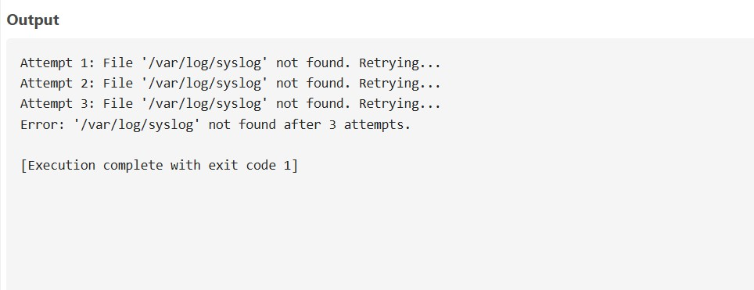

📷 Script 4 screenshot — insert from screenshots/script4_output.png

Script 5 — Open Source Manifesto Generator

This is the most interactive script. read -p prompts the user for three inputs: a daily open-source tool, a one-word definition of freedom, and something they would build and share. The script then uses string concatenation via echo and the >> append operator to write a personalised manifesto paragraph to a .txt file named after the current user via whoami. The date command provides a formatted timestamp. A helper function print_line is defined and called — demonstrating shell functions, which create named shorthands for sequences of commands, conceptually similar to aliases. The final manifesto is displayed with cat.

Shell concepts: read for interactive input, string concatenation, file redirection > and >>, date, whoami, shell functions, cat.

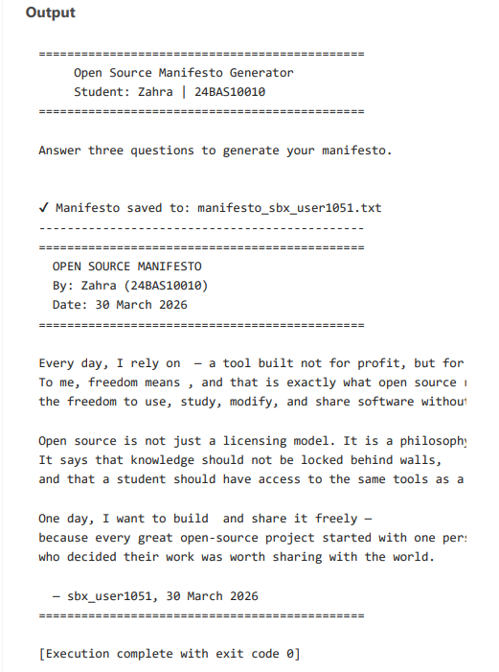

References

The Document Foundation. (2010). LibreOffice — About. https://www.libreoffice.org/about-us/who-are-we/

GNU Project. (2023). The Free Software Definition. https://www.gnu.org/philosophy/free-sw.html

Open Source Initiative. (2023). The Open Source Definition. https://opensource.org/osd

Mozilla Foundation. (2012). Mozilla Public License 2.0. https://www.mozilla.org/en-US/MPL/2.0/

Raymond, E. S. (1999). The Cathedral and the Bazaar. https://catb.org/~esr/writings/cathedral-bazaar/

Shotts, W. (2019). The Linux Command Line (2nd ed.). No Starch Press. https://linuxcommand.org

SPDX License List. (2024). MPL-2.0 and LGPL-3.0. https://spdx.org/licenses/

Meeks, M. (2010). The Birth of LibreOffice. https://blog.documentfoundation.org/blog/2010/09/28/

